CREDIT CARD APPROVAL PREDECTION

Project Description:
Banks and financial institutions receive thousands of credit card applications every day. A significant portion of these are rejected due to factors such as high existing loan balances, insufficient income levels, or excessive credit inquiries. Manually reviewing each application is both time-consuming and highly prone to human error, making it an inefficient process at scale.
This project automates the credit card approval decision using machine learning. By training a predictive model on historical applicant data, the system evaluates financial and demographic inputs to determine whether an applicant is likely to be approved or rejected just as real banks do. Four classification algorithms are applied: Logistic Regression, Random Forest, XGBoost (Gradient Boosting), and Decision Tree.
The best-performing model is saved and integrated into a Flask web application. The project also includes an IBM Watson Machine Learning deployment pipeline, enabling the solution to be hosted on the cloud for scalable, real-time credit card approval predictions accessible through an intuitive user interface.
Scenario 1: Automated Credit Card Application Screening
A bank credit analyst enters a new applicant’s financial profile including income type, employment duration, and credit history into the web application. The model returns an instant approval or rejection prediction, enabling the analyst to prioritize applications that require further review.
Scenario 2: High-Risk Applicant Identification and Compliance Review
A financial compliance officer uses the platform to batch-screen applicants with past-due loan records. The feature engineering pipeline converts multi-class payment status codes into binary labels, allowing the model to clearly classify high-risk applicants as ineligible for a new credit card.
Scenario 4: Customer Self-Service Credit Card Eligibility Check
A prospective customer uses the web application to enter personal and financial details such as income level, employment status, and credit history before submitting a formal credit card application. The system instantly predicts the likelihood of approval, helping the customer understand their eligibility and reducing unnecessary application rejections.

Technical Architecture:
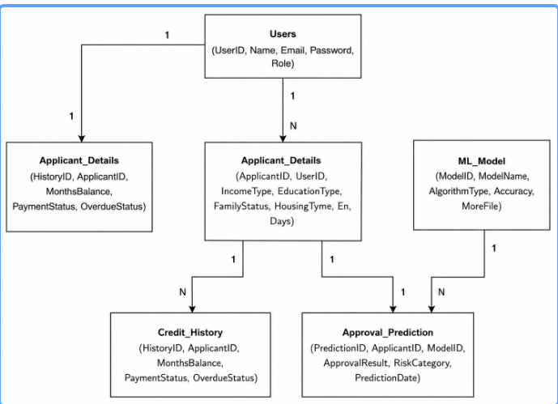
Description: The ER diagram represents the core entities involved in the Loan Approval Prediction System and illustrates how they interact with each other. It provides a clear structure for organizing applicant information, loan requests, prediction results, and machine learning model outputs within the database.
(Note: If you are using database in your project definitely you need to add ER Diagram along with description)

Pre-requisites

Anaconda Navigator: https://www.anaconda.com/download

PyCharm: https://www.jetbrains.com/pycharm/

NumPy: https://numpy.org/doc/stable/

Pandas: https://pandas.pydata.org/docs/

Scikit-learn: https://scikit-learn.org/stable/

Matplotlib: https://matplotlib.org/stable/

Seaborn: https://seaborn.pydata.org/

Flask: https://flask.palletsprojects.com/

The Credit Card Approval Prediction project follows a structured machine learning workflow to predict whether a credit card application should be approved or rejected.
The workflow begins with environment setup, dataset collection, data analysis, preprocessing, feature engineering, model training, model comparison, and final deployment.
Epic 1: Data Collection
- Story 1: Download the agricultural dataset and prepare it for analysis and machine learning model development.
Epic 2: Visualizing and Analysing the Data
- Story 1: Import the required Python libraries for data analysis, visualization, and machine learning.
- Story 2: Read and explore the dataset to understand its structure, features, and target variable.
- Story 3: Perform univariate analysis to examine the distribution of individual variables.
- Story 4: Conduct multivariate analysis to identify relationships among multiple agricultural factors.
- Story 5: Perform descriptive statistical analysis to summarize key characteristics and trends in the dataset.
Epic 3: Data Pre-Processing
- Story 1: Identify and remove duplicate records to improve data quality.
- Story 2: Detect and handle missing values to ensure dataset completeness.
- Story 3: Perform data cleaning and merging operations to create a consistent dataset.
- Story 4: Apply feature engineering techniques to create meaningful features for model training.
- Story 5: Convert categorical variables into numerical representations suitable for machine learning algorithms.
Epic 4: Model Building
- Story 1: Train a Logistic Regression model and evaluate its crop prediction performance.
- Story 2: Build and test a Random Forest model to improve classification accuracy.
- Story 3: Develop a Decision Tree model and analyze its effectiveness in recommending crops.
- Story 4: Compare the performance of all trained models using suitable evaluation metrics and select the best-performing model for deployment.
Epic 5: Application Building
- Story 1: Design and develop HTML pages to provide a simple and user-friendly interface.
- Story 2: Build the Python application and integrate the trained crop recommendation model.
- Story 3: Run, test, and validate the application to ensure accurate crop recommendations and smooth functionality.

ou need a valid Groq API key. Follow the steps below to create one and connect it securely to the project.
EPIC 1 :Data collection:
You can collect datasets from various open-source repositories such as Kaggle, data.gov, and the UCI Machine Learning Repository. For this project, download the credit card approval prediction dataset from the link below:
Dataset Link: https://www.kaggle.com/datasets/mlg-ulb/creditcardfraud
The dataset consists of two inter-related CSV files that are later merged during the pre-processing stage. The first file contains applicant demographic and financial information, while the second contains credit
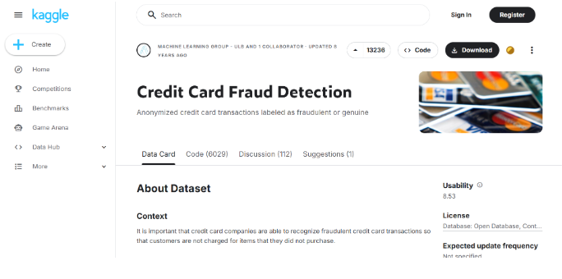

Epic 2 : Visualizing and Analysing the Data
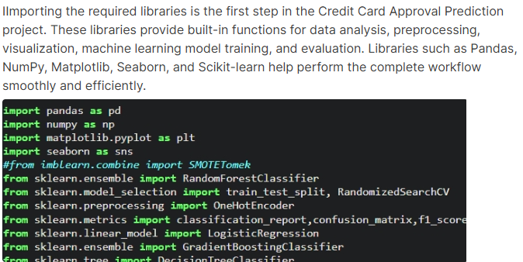

READ THE DATASET:
Reading the dataset is an important step in the Credit Card Approval Prediction project because it helps understand the structure, features, and records available for machine learning. The dataset is loaded using the Pandas library with functions such as pd.read_csv_() to read CSV files and store them in a DataFrame for analysis and preprocessing. Functions like head(), shape, and info() are used to display sample records, dataset size, column names, data types, and missing values before model training.
In pandas we have a function called read_csv() to read the dataset. As a parameter we have to give the directory of csv file.
head
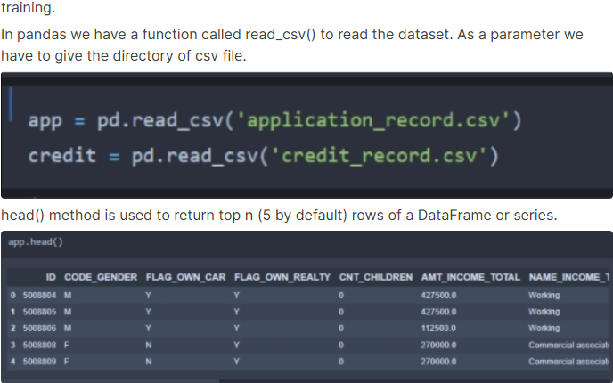

Univariate Analysis
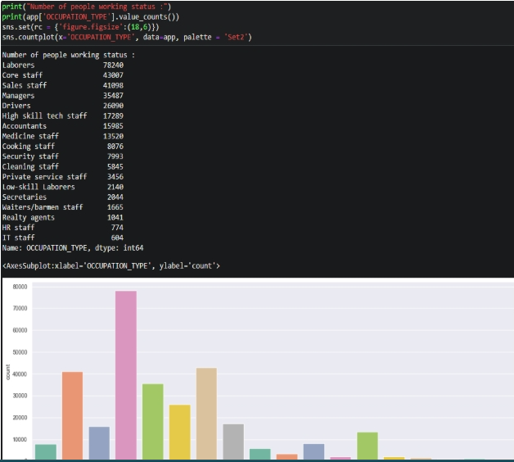

Epic 3 : Data Pre-processing

Drop Duplicate Features:
Removing duplicate records is an important preprocessing step in the Credit Card Approval Prediction project because each applicant should have a unique Applicant ID. Duplicate records may occur due to repeated data entry, merged files, or system errors, which can affect the accuracy and performance of the machine learning model.
To remove duplicate records, the drop_duplicates() function from the Pandas library is used. Commands such as df.drop_duplicates() or df.drop_duplicates(subset='Applicant_ID', keep='first') help remove repeated rows and keep only unique applicant records in the dataset.
After removing duplicates, the dataset becomes cleaner, more accurate, and reliable for preprocessing, feature selection, train-test splitting, and machine learning model training.

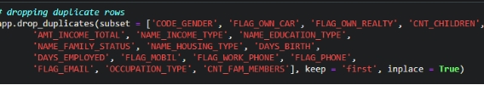

Handling Missing Values
Handling missing values is an important preprocessing step in the Credit Card Approval Prediction project because missing data can reduce model accuracy and create errors during training. The functions df.isnull().sum() and df.isnull().mean() are used to identify and measure missing values present in each column of the dataset.
The isnull() function checks whether any value is missing, while sum() counts the total missing values and mean() calculates the proportion of missing data in each feature. In this dataset, the occupation type column contains null values, but it is removed during the cleaning process because it is not required for final model training.
After checking the remaining columns, no missing values are found, so further imputation is not required. This process ensures that the dataset is clean, complete, and ready for preprocessing, feature selection, scaling, and machine learning model training.

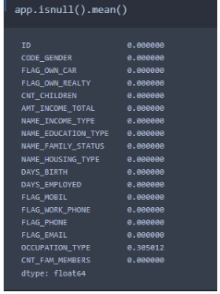

Data Cleaning and Merging:
Data Cleaning and Feature Transformation is an important preprocessing step in the Credit Card Approval Prediction project. The data_cleaning() function is used to clean, transform, and prepare the applicant dataset before machine learning model training. Raw datasets may contain unnecessary columns, negative values, inconsistent information, and categorical features that must be converted into a useful format for analysis and prediction.
In this process, a new column is created by combining family members and children information to better represent family dependency. Unnecessary columns are removed to reduce complexity and improve model performance. The DAYS_BIRTH and DAYS_EMPLOYED columns contain negative values, so the abs() function is used to convert them into positive values for easier interpretation and analysis.
Feature mapping is applied to categorical columns such as housing type, income type, education type, and family type to convert text values into numerical labels suitable for machine learning algorithms. For the credit records dataset, the data is grouped using the ID column to combine multiple monthly records for each applicant. New features such as open_month, end_months, and window are created from the MONTHS_BALANCE column to represent the applicant’s credit activity period. The STATUS column is also interpreted to identify payment behavior such as timely payments, overdue payments, and no loan records, which helps improve credit approval prediction accuracy

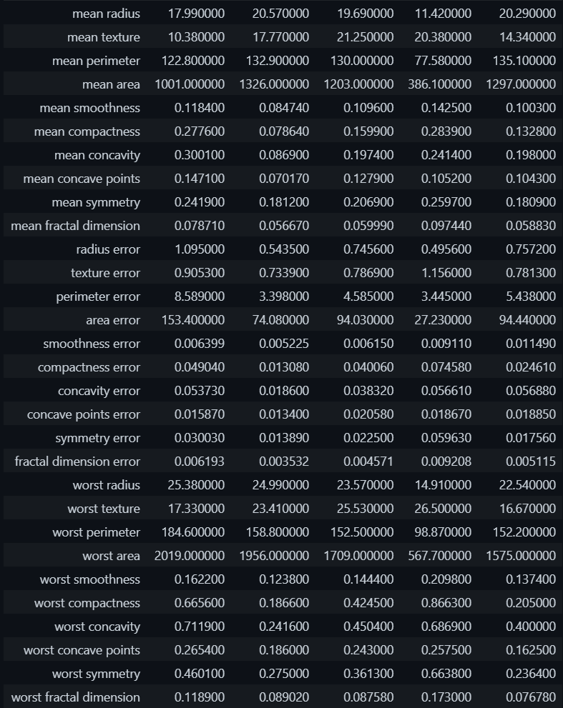

Handling Categorical Values:
In this process, the LabelEncoder class from the scikit-learn preprocessing module is used. The fit_transform() method identifies unique category names in each column and converts them into integer values. This transformation makes the dataset suitable for machine learning algorithms and helps models learn patterns from categorical data efficiently.
The encoded values are only numerical representations of categories and do not represent ranking or importance. Tree-based models such as Decision Tree, Random Forest, and XGBoost can effectively work with label encoded features during prediction and classification.

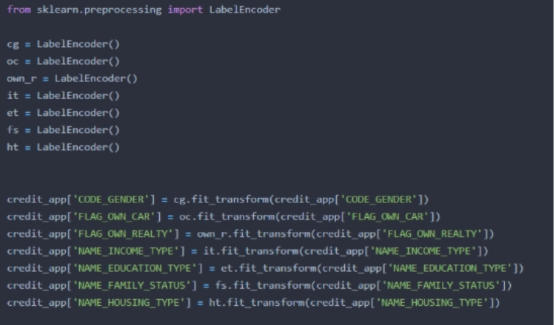

Epic 4 : Model Building:

Logistic Regression Model:

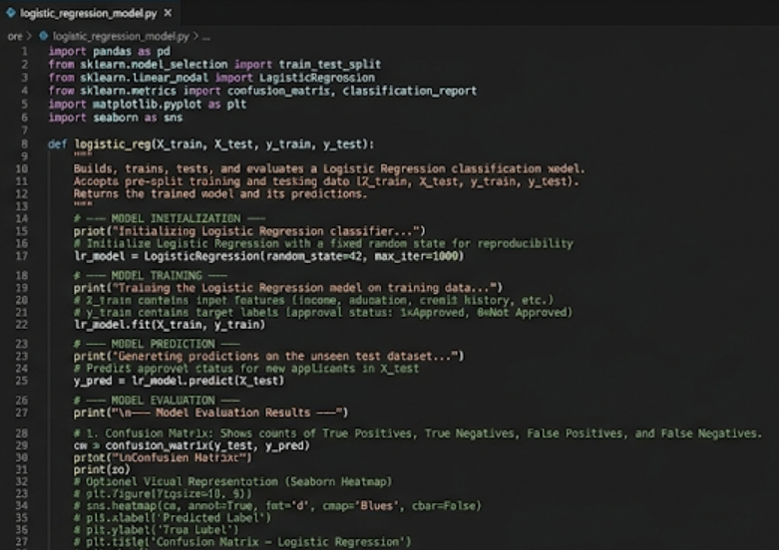

Decision Tree Model:
Decision Tree is a supervised machine learning algorithm used for classification and prediction tasks. In the Credit Card Approval Prediction project, a function named d_tree() is created to train, test, and evaluate the Decision Tree model using X_train, X_test, y_train, and y_test datasets. The model predicts whether a credit card application should be approved or not approved based on applicant and credit-related information.
The DecisionTreeClassifier() class from the scikit-learn library is initialized and trained using the fit() method. The algorithm works like a flowchart where decisions are made based on feature conditions, and the predict() method is used to generate predictions on unseen test data. The predicted values are compared with actual values to measure model accuracy and performance.
The model is evaluated using a confusion matrix and classification report, which provide metrics such as precision, recall, F1-score, and support. Decision Tree is easy to understand, interpretable, and effective for handling both numerical and categorical features in classification problems.

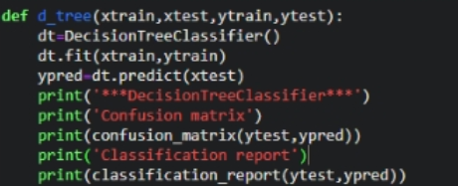

Epic 5 : Application Building:

This phase involves developing and integrating all core components of the application into a functional system. It focuses on implementing features, connecting services, and ensuring smooth end-to-end functionality.

Building HTML Pages:
Three HTML pages are created and stored inside the templates/ folder to build the frontend of the Credit Card Approval Prediction application. The home.html page acts as the landing page and provides a project overview along with a navigation button to access the prediction form. The index.html page contains the input form where users enter applicant financial and demographic details required for prediction. The result.html page displays the final prediction result showing whether the credit card application is approved or rejected.
In this milestone, a Flask web application is developed and integrated with the trained machine learning model to provide real-time prediction through a web interface. The Flask application acts as a bridge between the frontend HTML pages and the backend machine learning model. User inputs entered through the form are collected in the backend, processed, and passed to the trained model for prediction.
The app.py file is used as the main backend script of the Flask application. It handles routing, model loading, input processing, prediction generation, and result rendering. The trained model is loaded using Pickle or Joblib, and Flask routes are created to display the home page, prediction form, and result page. When the user submits the form, the entered values are processed and passed to the model using the predict() method to generate the final approval prediction.

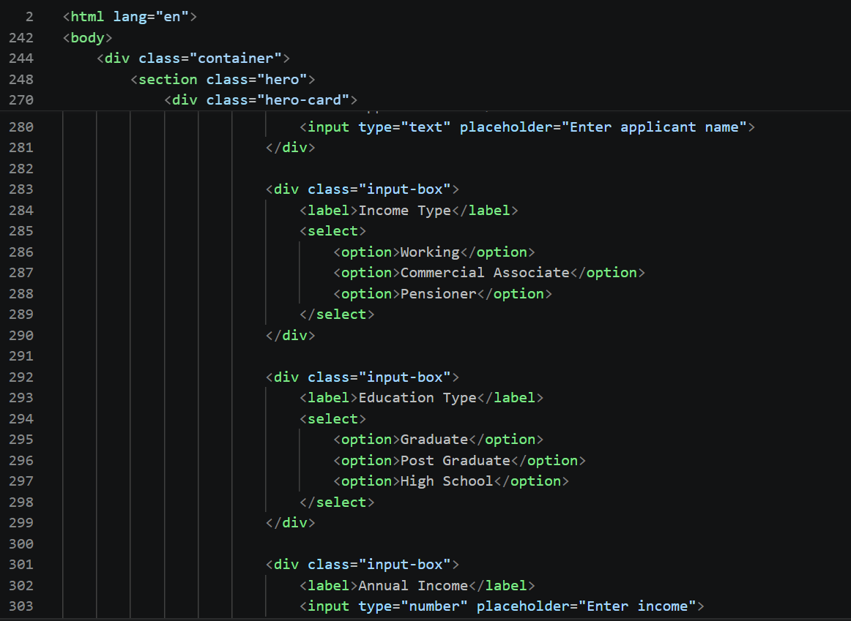

Run the Application:
Running the Flask Application is the final step used to test the Credit Card Approval Prediction system locally. First, open Anaconda Prompt and navigate to the project folder containing the app.py file using the cd command. Then run the application using the command python_app.py, which starts the Flask development server and generates a localhost URL such as http://127.0.0.1:5000/.
Open the localhost URL in a web browser to access the application. The index.html page displays the home screen, and the user can navigate to the prediction form page to enter applicant details. After submitting the form, the Flask backend processes the input values, loads the trained machine learning model, and generates the prediction result.
The final approval or rejection result is displayed on the result.html page. This step confirms that the frontend pages, Flask backend, trained model, and prediction logic are properly connected and working successfully.

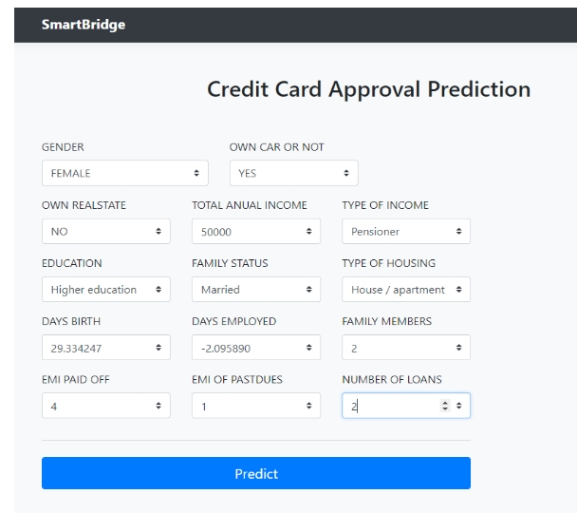

Conclusion:
The Credit Card Approval Prediction System successfully demonstrates how machine learning can be utilized to automate and enhance the credit card approval process in the banking and financial sector. The project analyzes important applicant details such as income type, employment status, family status, housing type, and credit history to determine whether a credit card application should be approved or rejected.
The system follows a complete machine learning pipeline, including data collection, data preprocessing, data visualization, feature engineering, categorical encoding, model training, testing, and performance evaluation. Various classification algorithms such as Logistic Regression, Decision Tree, Random Forest, and XGBoost are implemented and compared to identify the most accurate and efficient prediction model.
The best-performing model is integrated into a Flask-based web application that provides a user-friendly interface for bank staff or users to enter applicant details and instantly receive approval prediction results. Additionally, the project incorporates IBM Watson Machine Learning for cloud deployment, enabling scalable and real-time prediction services.
Overall, the project provides hands-on experience in machine learning, data analysis, Flask web development, cloud deployment, and financial risk assessment while addressing a real-world banking and credit approval challenge efficiently and accurately.

